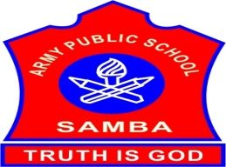
ARMY PUBLIC SCHOOL SAMBA
WEEKLY REPORT
SEPTEMBER 04,2023- SEPTEMBER 09,2023

SCHOOL EVENTS

INTER HOUSE BADMINTON MATCH FOR (BOYS AND GIRLS) CLASSES III-V ( FINALS)(SEPTEMBER 04,2023)
The Inter-House Badminton final matches for the students of classes III-V (Boys and Girls) was organized on September 04,2023 in the MP Hall of APS Samba.The students from all the four houses took part in the competition with high sportsman spirit.The result of the competition is as follows:
First Position – Teresa House
Second Position – Sarojini House
Third Position – Nehru House
Fourth Position – Gandhi House
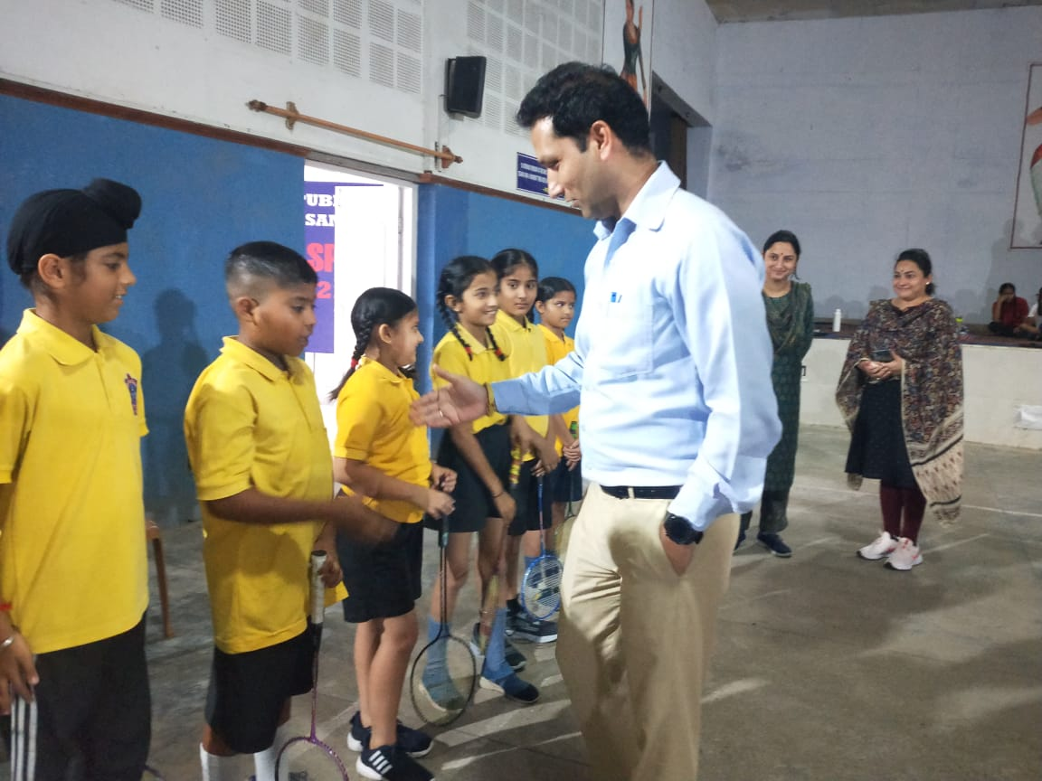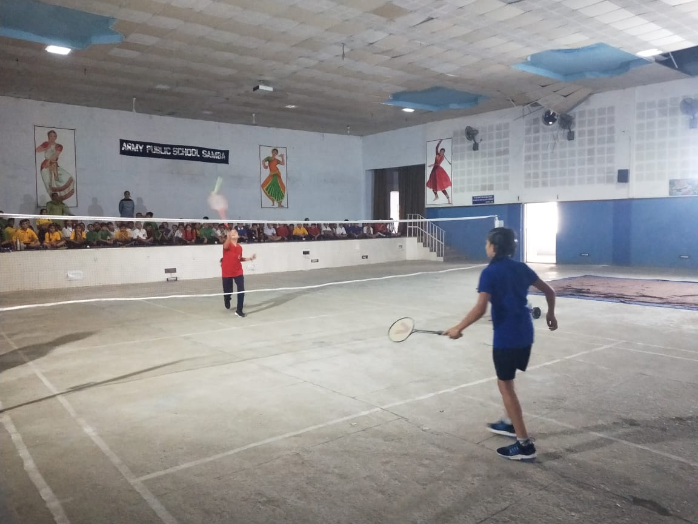
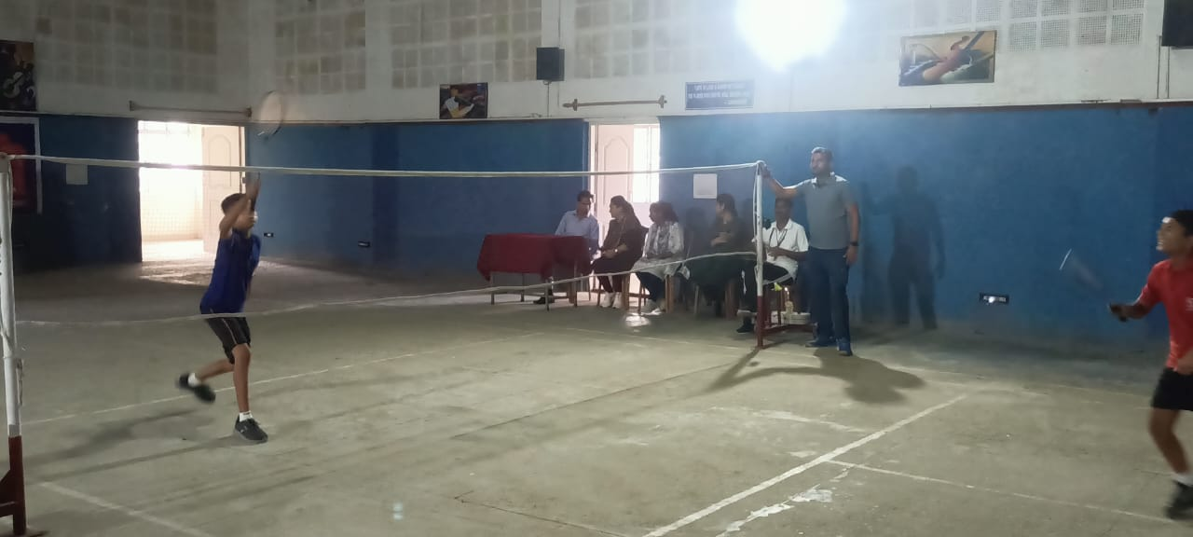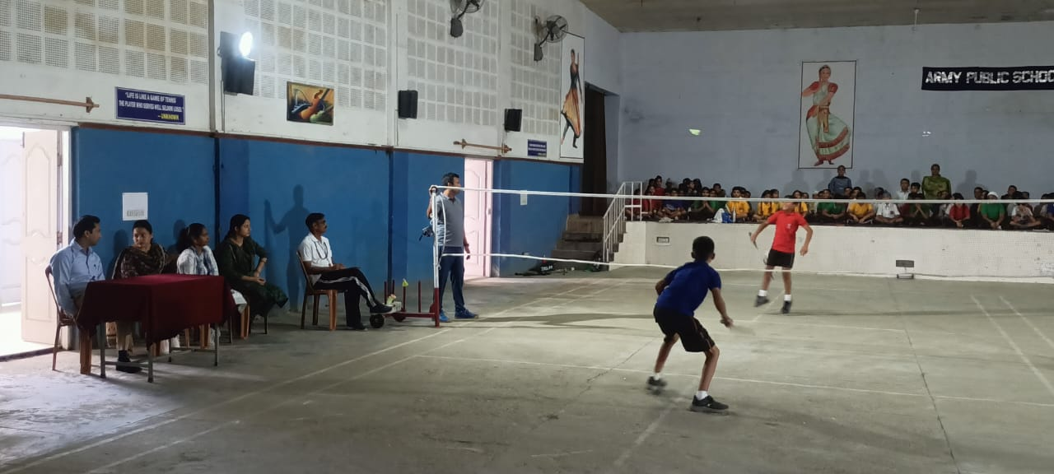
INTER SCHOOL DISTRICT LEVEL TABLE TENNIS TOURNAMENT (SEPTEMBER 04,2023)
Inter School District Level Table Tennis Tournament was conducted by Department of Youth Services and Sports on September 04,2023 at Samba Auditorium.Students from APS Samba also participated in this tournament and two students got selected for the next tournament.
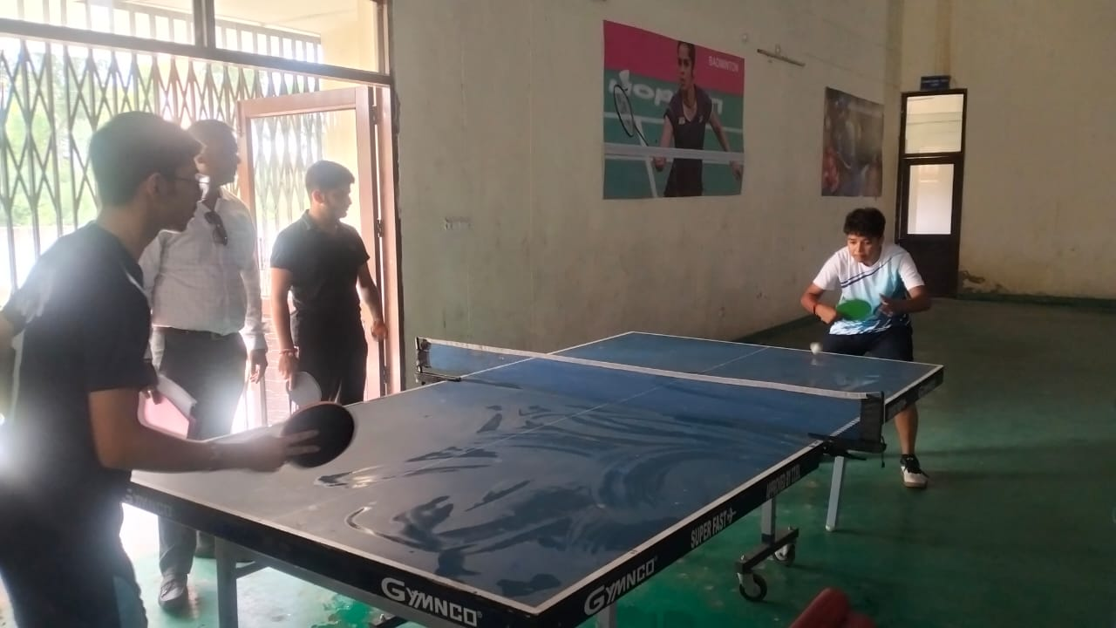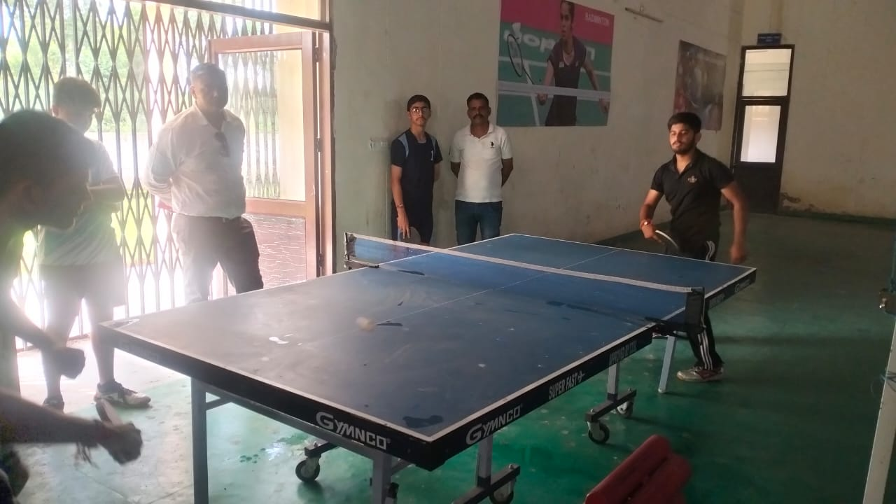

PRE-NATIONAL SHOOTING TOURNAMENT (AUGUST 26,2023 - 08 SEPTEMBER,2023)
Pre- National Shooting Tournament conducted by NRA was held at New Delhi from August 26,2023 to September 08,2023. Two students – Akriti Sharma and Udhaybir Singh Sandhu(sub youth) 10m pistol from APS Samba also participated in this tournament.
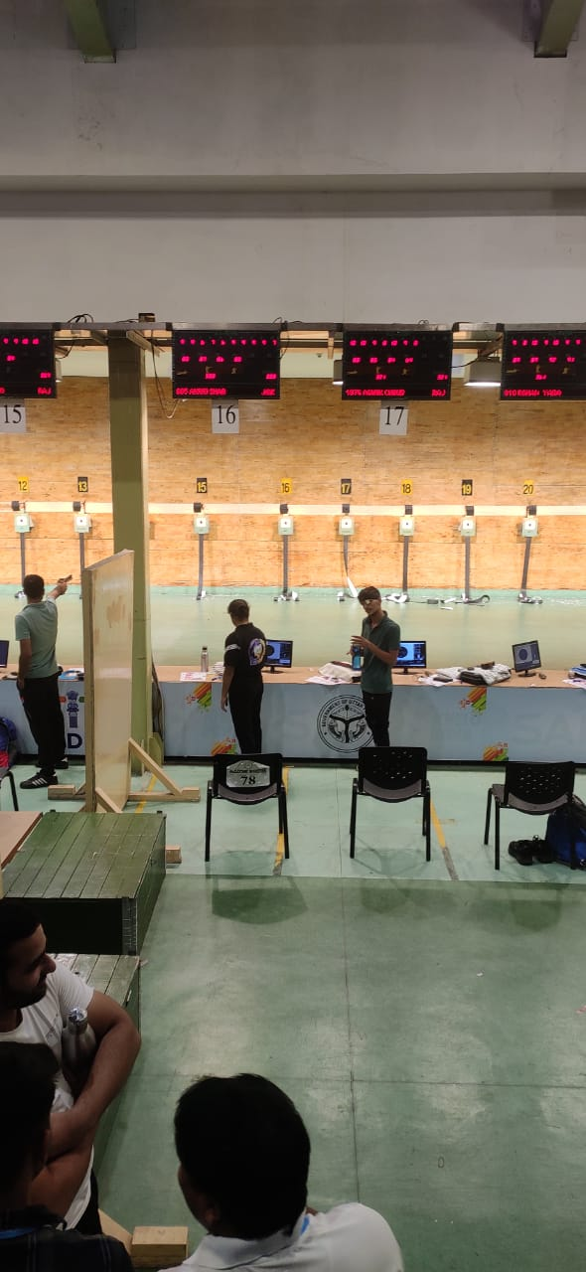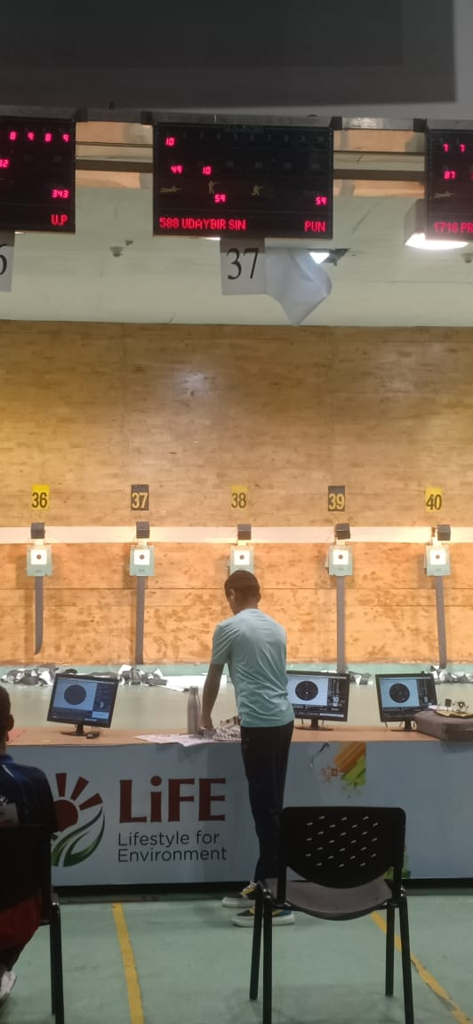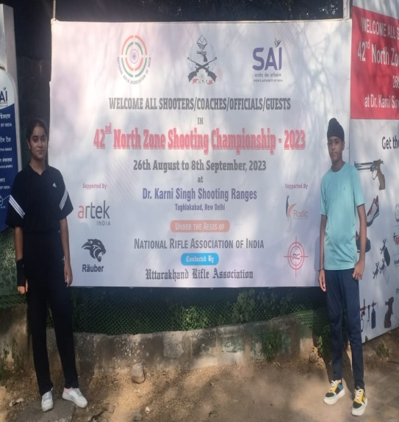
CLUSTER LEVEL HINDI DEBATE COMPETITION (SEPTEMBER 04,2023)
Three students from APS Samba participated in Inter School Cluster Level Hindi Debate Competition which was conducted by APS Damana on September 04,2023.The topic for the debate competition was – “Kya Bharat Vishav Guru Banne Ke Path Par Agrasar Hai”.
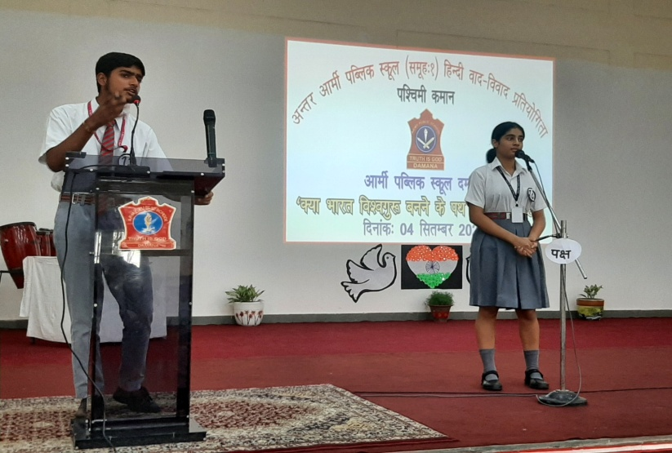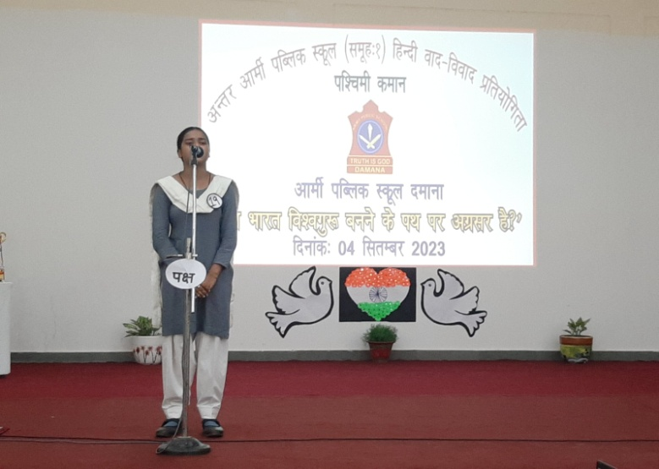
NIAS-ALC OFFLINE SESSION (SEPTEMBER 07,2023)
Offline session of NIAS- ALC was conducted on September 07,2023.The topic of discussion for the class was- “ Python based project,Facial Recognition,price comparison and colour detection. Class was fully interactive and students took part in the discussion with great interest.
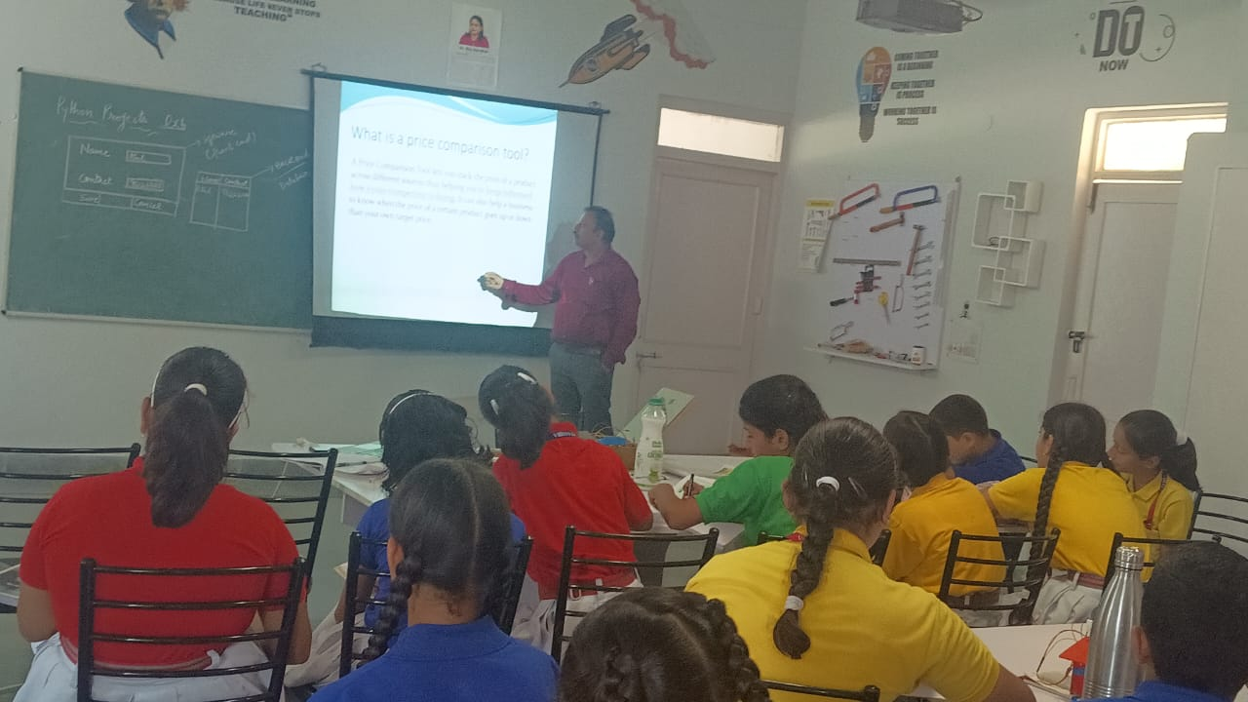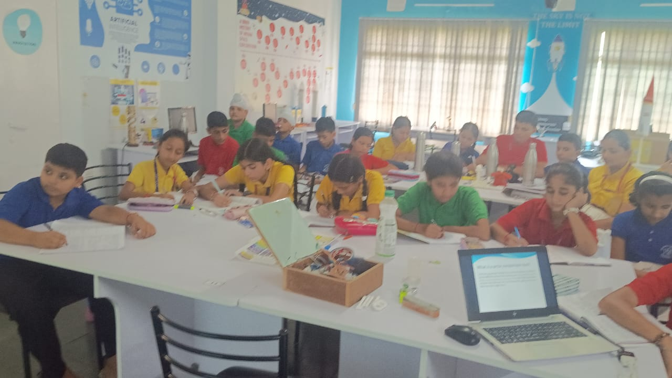
NCC DRILL PRACTICE AND CLASS ON FC/BC (SEPTEMBER 06,2023)
To help NCC cadets in the mass movement in an orderly manner from point to point and to inculcate a sense of discipline, smartness, alertness and to develop a quality of immediate response to the orders, a drill practice was given to the NCC Girl cadets by Hav T.Raj on September 06,2023 at APS Samba. Classes on FC/BC were also conducted.

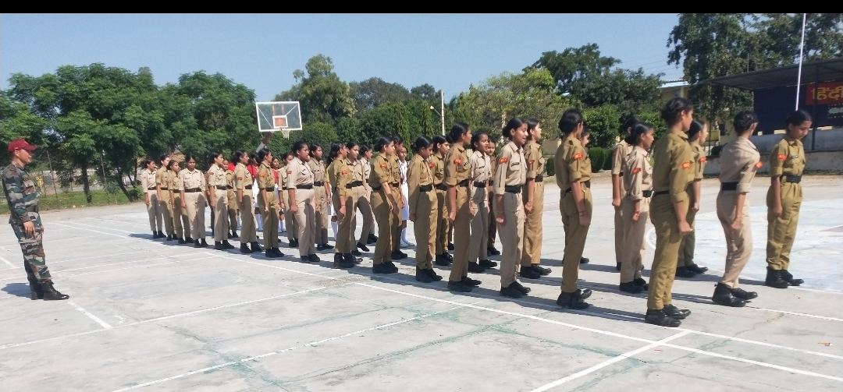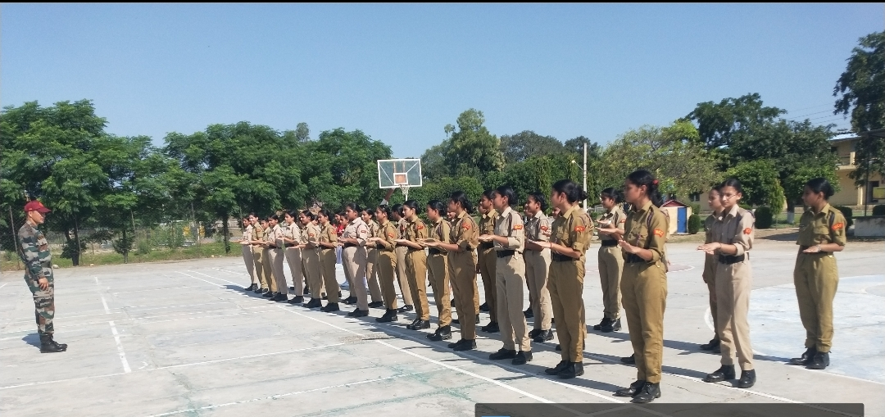
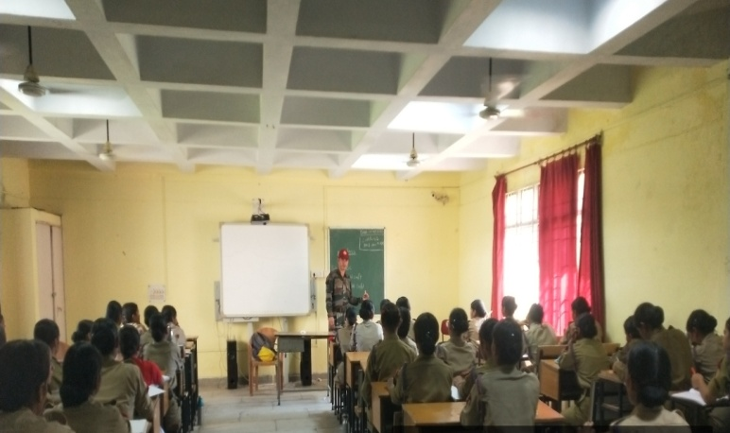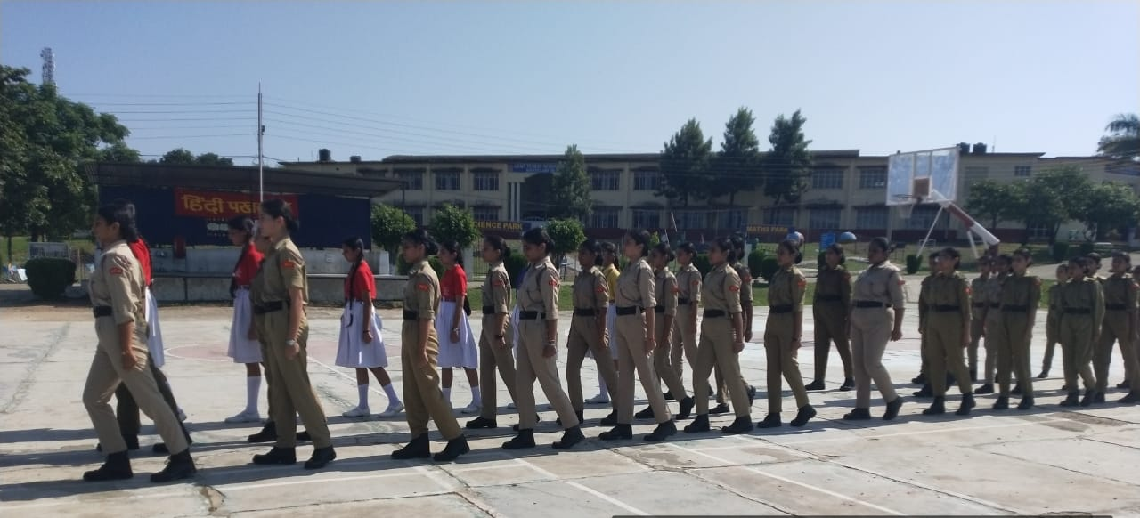
JANAMASHTAMI CELEBRATION (SEPTEMBER 09,2023)
To mark the celebration of Janamashtami, a special morning assembly was organized on September 09,2023 by APS Samba.On this occasion, a semi classical dance performance related to Lord Krishna was presented by the girls of classes VI and IX.
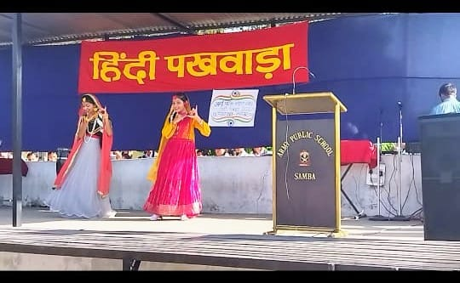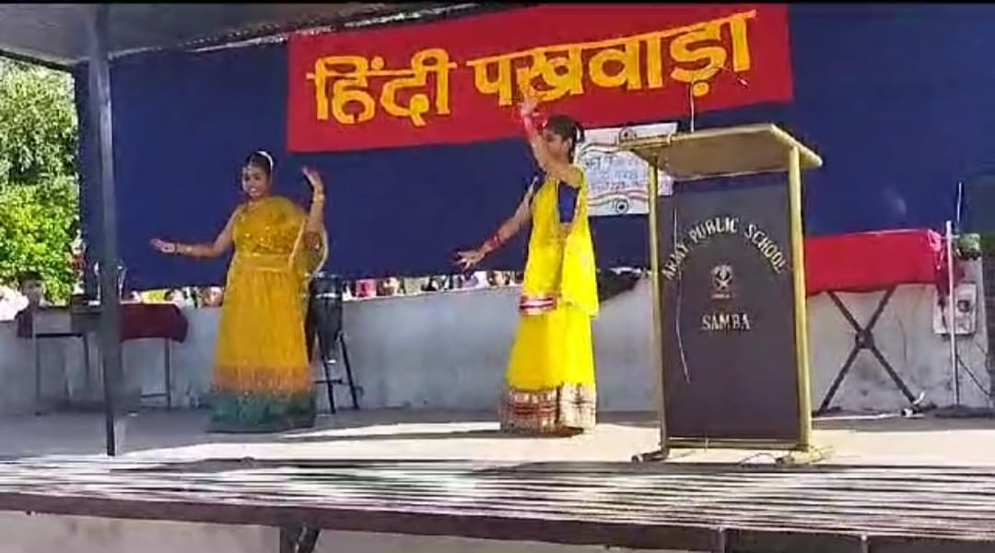
INTER SCHOOL ZONE KHO-KHO AND VOLLEY BALL FOR U-19 BOYS COMPETITION (SEPTEMBER 09,2023)
An Inter-school Kho-Kho and Volley Ball competition for U-19 boys,conducted by Department of Youth Services and Sports was held on September 09,2023 at Samba.Students from APS Samba also participated in these competitions and two students of Kho-Kho team of APS Samba are selected for district level competition.
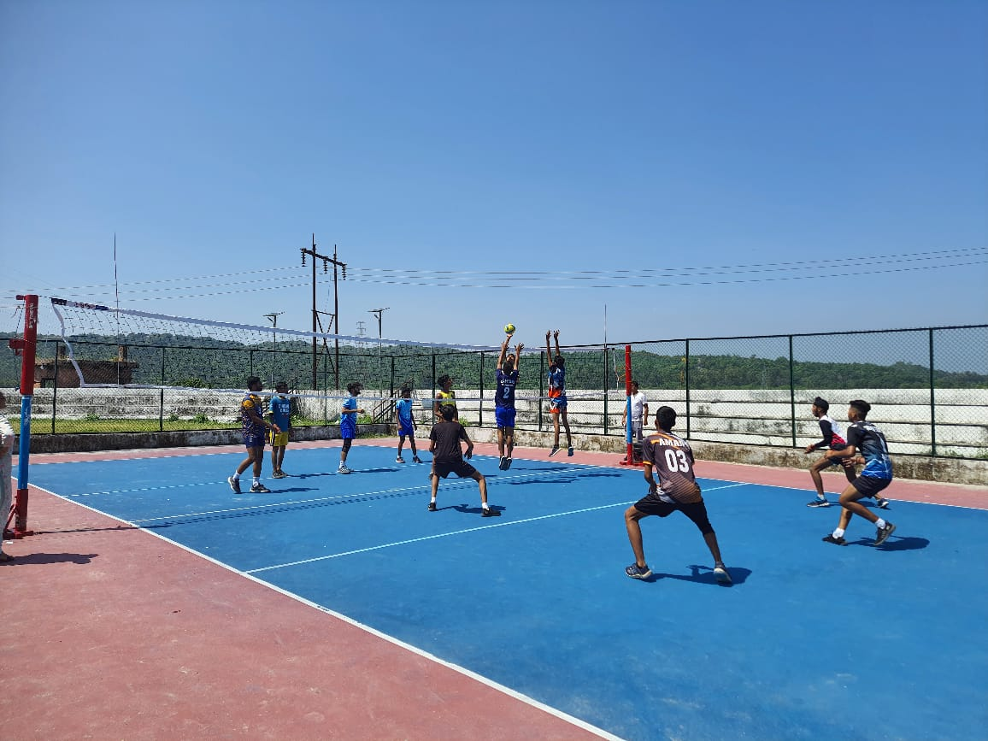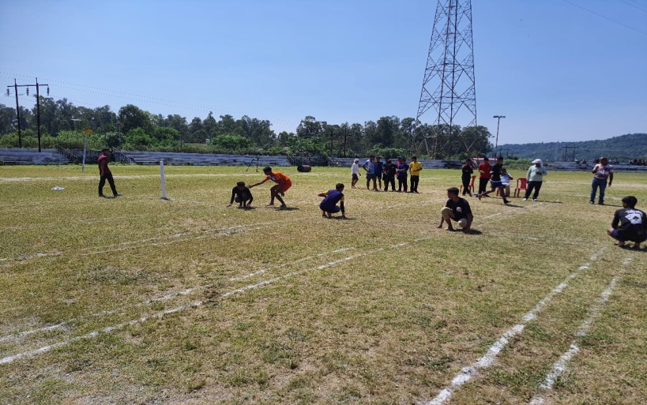

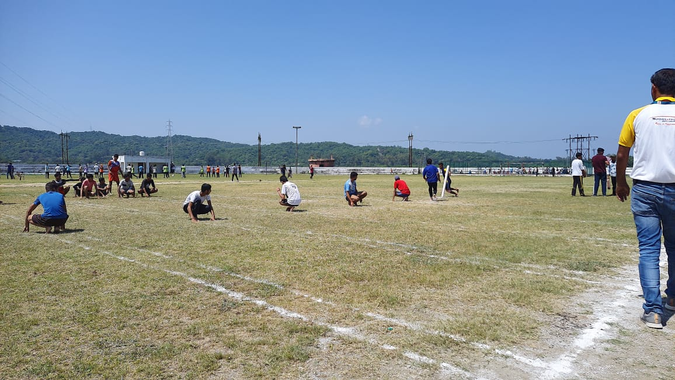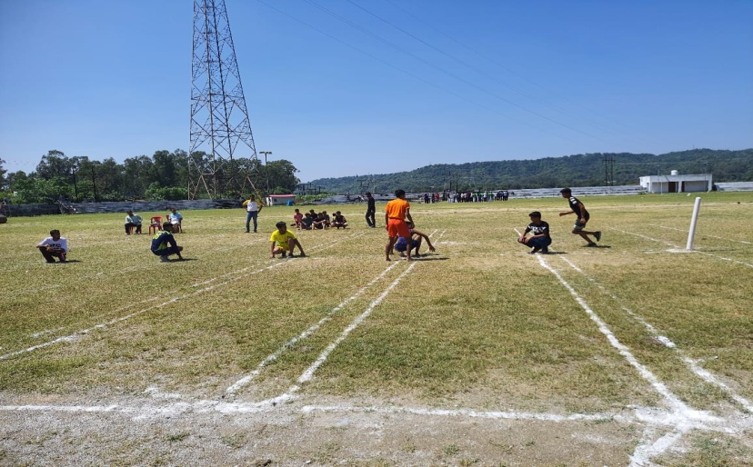

WORKSHOP ON- ‘HAPPINESS – A WAY OF LIVING’ (SEPTEMBER 09,2023)
A workshop for the Primary teachers was conducted by Ms Ravneet Kaur (PRT)on September 09,2023 in the Primary Block of APS Samba on the topic: ‘HAPPINESS – A WAY OF LIVING’.All the Primary teachers attended the workshop.
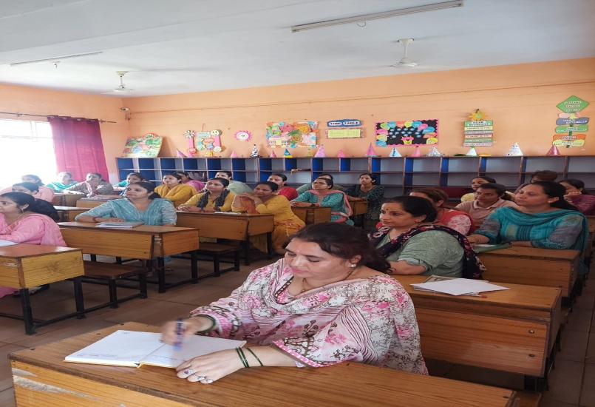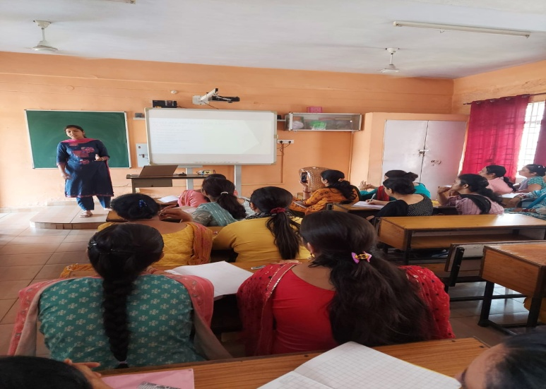
TEACHERS’ DAY CELEBRATION (SEPTEMBER 05,2023)
Teachers’ Day was celebrated on September 05,2023 at APS Samba with great pomp and grandeur. On this occasion ,a special assembly was organized in the Primary as well as Secondary Block of the school. The students performed various cultural activities like dance, song, recitation, drama, etc. A student of class X also delivered a beautiful speech. The Principal,in his speech appreciated the performances of the students.
A cultural programme was also presented by the students of classes XI and XII in the afternoon in the MP Hall of the school which was beautifully decorated with flowers and festoons.
The Principal of the school Mr Sanjeev Pradhan inaugurated the program by lighting the lamp and by garlanding the portrait of Dr. Sarvapalli Radhakrishnan. After that various dances and acts were presented by the students.Various games like saree draping,ramp walking,dancing on paper etc. were there for the teachers.There was a quiz also for the teachers in which they participated with full enthusiasm.In the end, the Principal gave a brief speech on Dr Sarvapalli Radhakrishnan and explained the significance of Teachers’ Day. 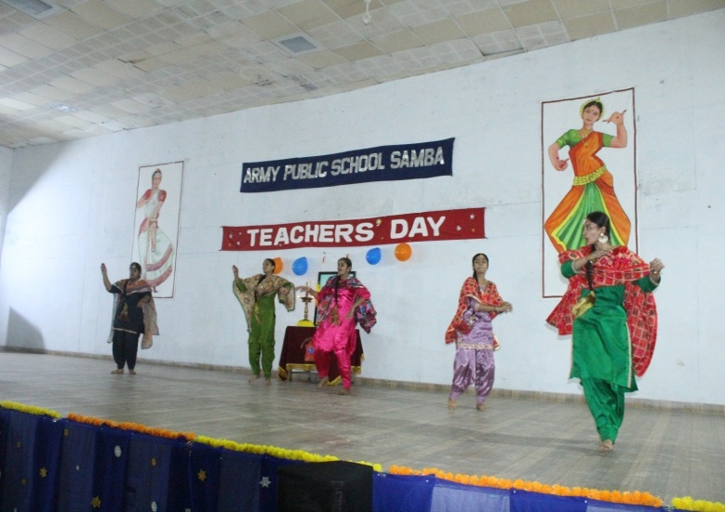 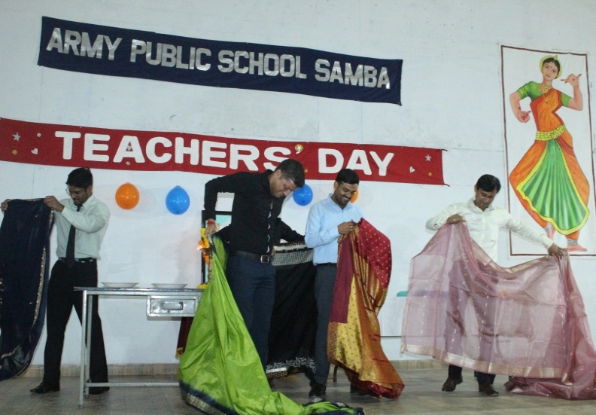

HINDI PAKHWADA (SEPTEMBER 01-09,2023)
The staff and students of Army Public School Samba celebrated Hindi Pakhwada from September 01- 09, 2023 in the school as a mark of acknowledgement of HINDI as the National Language. To celebrate this day various competitions were organized for the students during the special morning assembly:
Nara Lekhan class -VII, Kavita Vachan class-VI, Aashu Bhashan Pratiyogita class-IX , Hindi Bhashan Pratiyogita class-XI.
Students of grade VIII participated in Doha Gayan Pratiyogita wherein the audience were enthralled & spellbound with the fluent language spoken by the students. The grand finale of the celebration was a well-choreographed dance performance of Krishna & Radha which was well appreciated & loved by the audience.
The Principal, Mr Sanjeev Pradhan, speaking on the occasion emphasized that we should be proud of our national language & should learn to speak in public domain without any hesitation.He also gave an insight and importance of Hindi Dohas in our daily life. Language and culture of any country plays an important role in making people to connect with the people & helps in making a strong nation. Thus, the celebration concluded with a positive note.

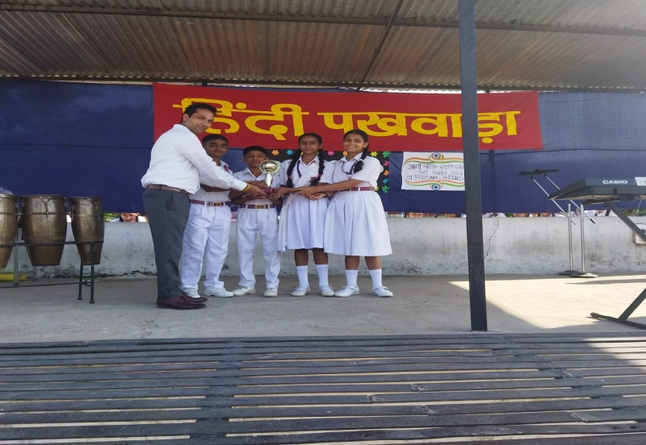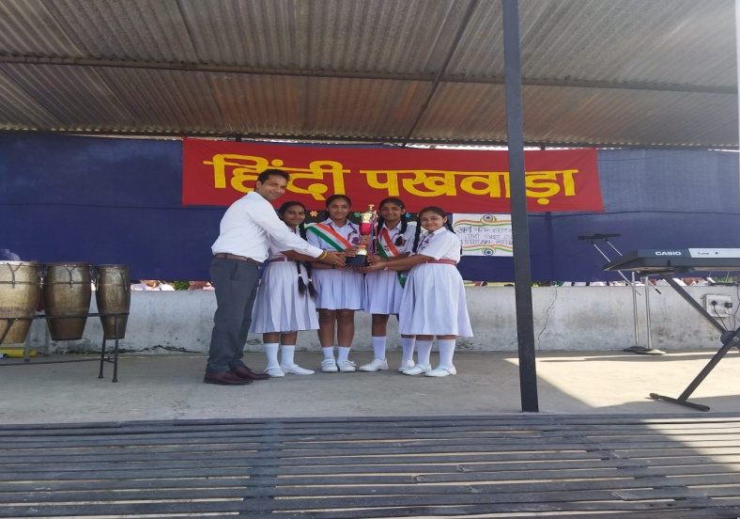

THANK YOU

